Name :- Purushottam Kumar

ID :- 2041

MCA I-Sem (R)

Submission Date :- 12-Mar-2021

**Python Lab session 10 (12-03-2021)**

**File-Handling Assignment**

1. Write a program that reads text from a file and writes it into another file but in the reverse order.

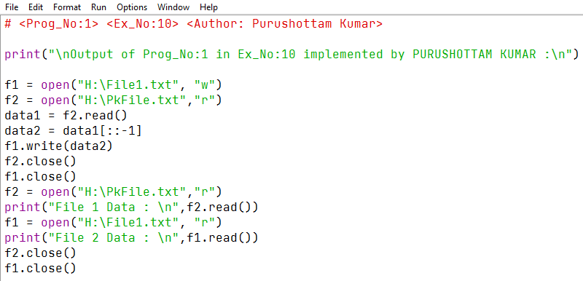

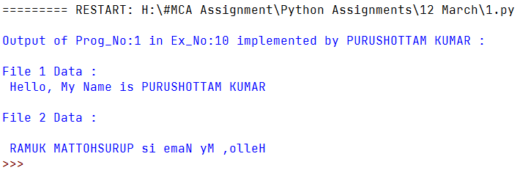 **OUTPUT**

1. Write a program that reads a file and prints only those lines that has the word ‘The’.

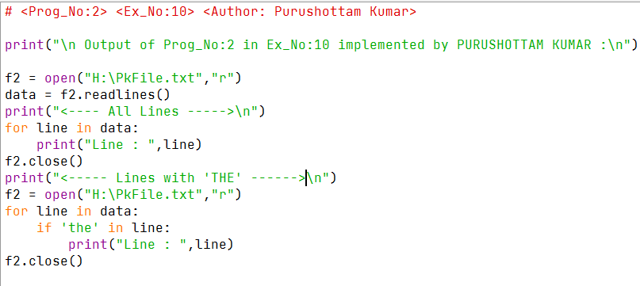

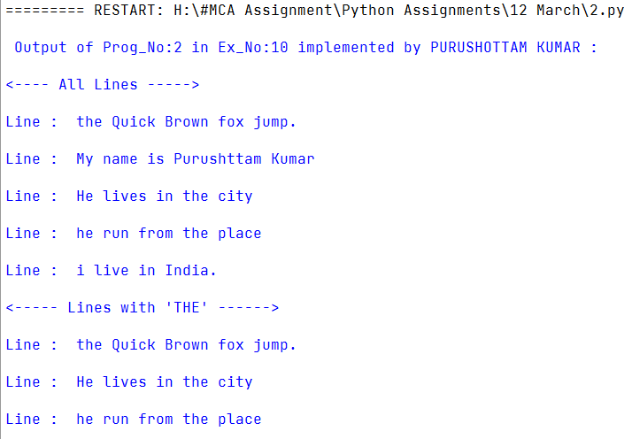 **OUTPUT**

1. Write a program to read a file containing text with line numbers and copy the line in another file without the line numbers.

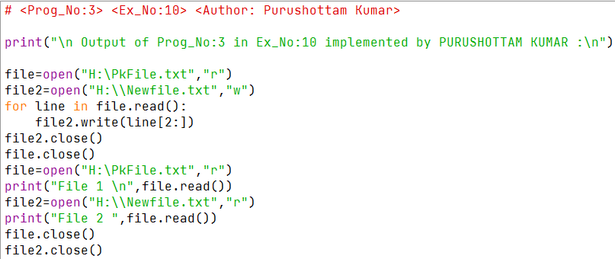

**OUTPUT**

1. Write a program to compare two files.

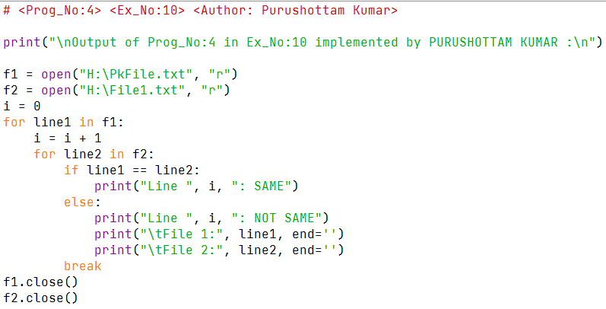

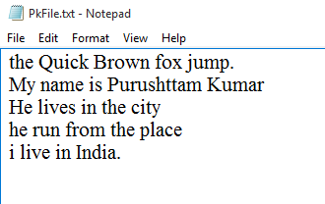

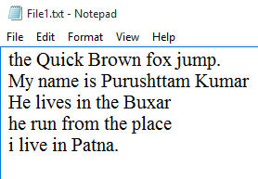

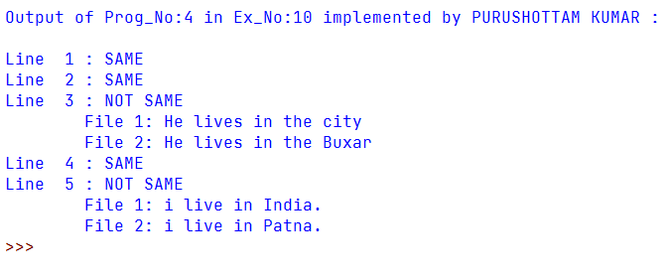 **OUTPUT**

1. Write a program to copy one file into another. Copy character by character.

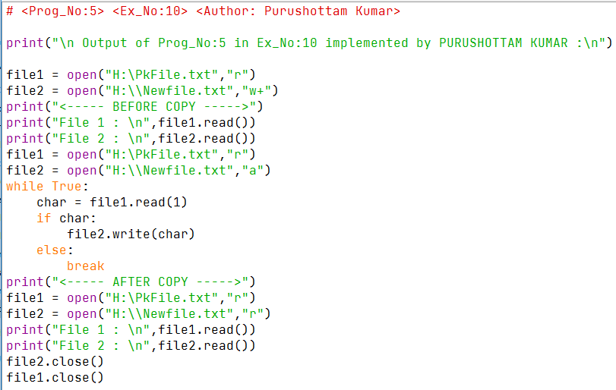



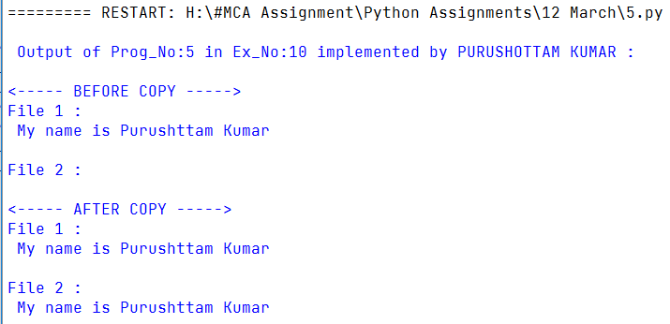

1. Write a program to read and write the details of a student in a file.

**( Program – 6 )**

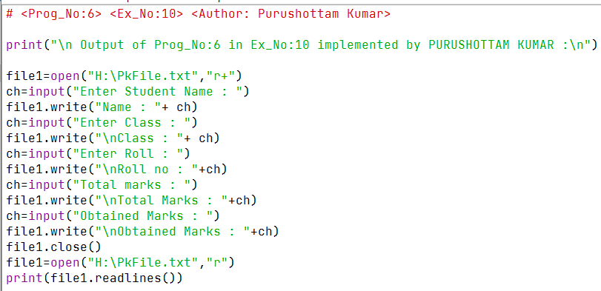



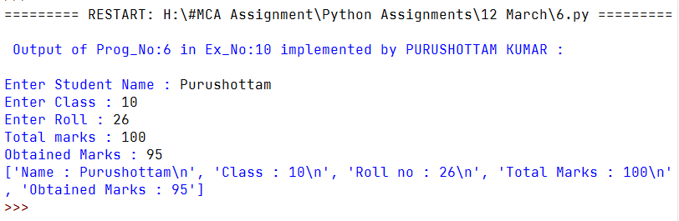

1. Write a program to count the number of records stored in file named “Employee”.

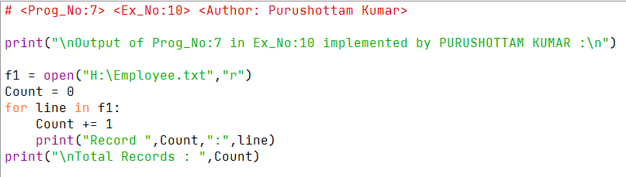



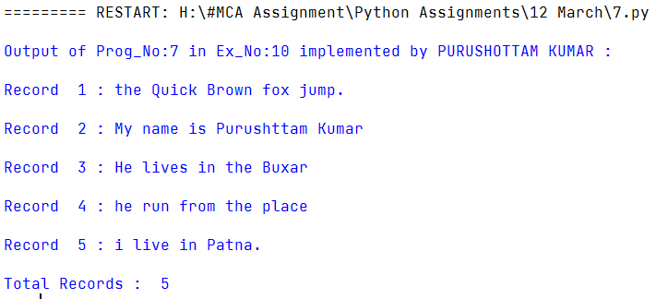

1. Write a program that reads a file and prints the number of lines in that file.

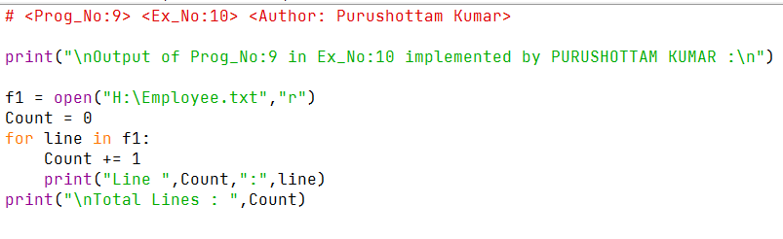



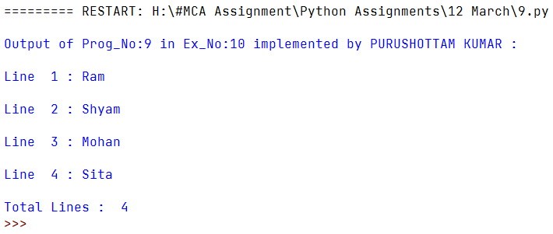

1. Write a program that reads a file and prints the number of characters, special symbols, digits and words. Also write the words in another file in new line.

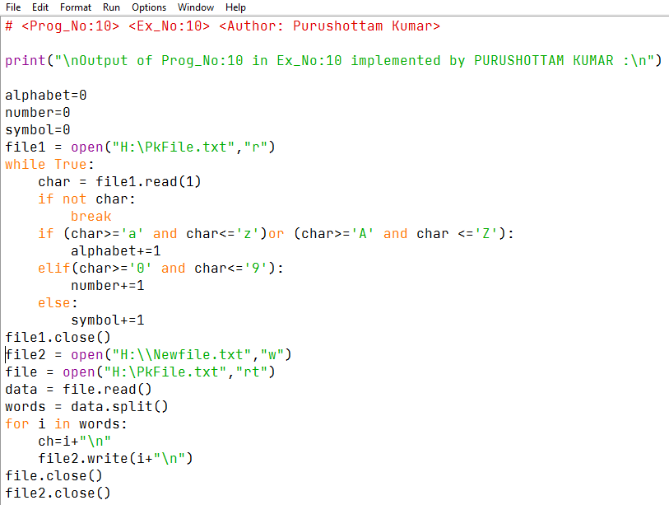

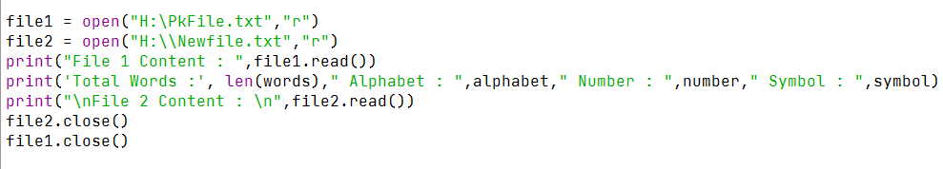

**OUTPUT**

